LABORATORIYA ISHI №4
Mavzu: PHP orqali MySQL ma’lumotlar bazasiga ulanish

1. Ishning maqsadi
- Tayyor MySQL bazaga PHP orqali ulanish
- SELECT so‘rovlarini bajarish
- INNER JOIN orqali bir nechta jadval ma’lumotlarini chiqarish
- MySQLi (procedural, OOP) va PDO usullarini taqqoslash
- Ular orasidagi farqlarni amaliy ko‘rsatish

2. Nazariy qism
PHP orqali MySQL bilan ishlashning 3 asosiy usuli mavjud:
- MySQLi (Procedural)
- MySQLi (Object-Oriented)
- PDO (PHP Data Objects)


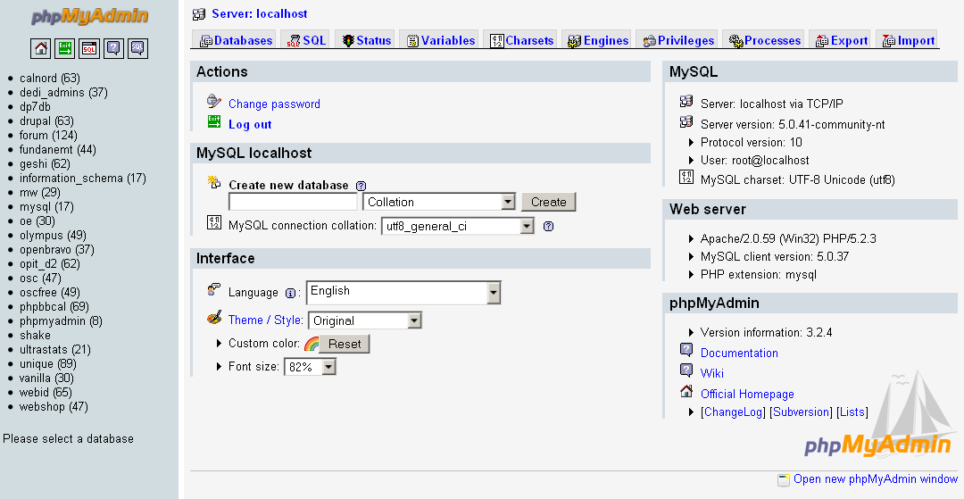

3. Amaliy baza (tayyor database)
Database: db_universitet
3 ta jadval:
fakultetlar
- id (PK)
- nomi
talabalar
- id (PK)
- ism
- kurs
- fakultet_id (FK)
fanlar
- id (PK)
- fan_nomi
- kredit
- talaba_id (FK)

4. Oddiy SELECT so‘rovi
SELECT * FROM talabalar;

5. JOIN so‘rovi
SELECT
talabalar.ism,
talabalar.kurs,
fakultetlar.nomi AS fakultet,
fanlar.fan_nomi
FROM talabalar
INNER JOIN fakultetlar ON talabalar.fakultet_id = fakultetlar.id
INNER JOIN fanlar ON talabalar.id = fanlar.talaba_id;

6. PHP orqali ulanish usullari
6.1 MySQLi – Procedural usul
<?php
$conn = mysqli_connect("localhost", "root", "", "db_universitet");
if (!$conn) {
die("Ulanish xatoligi: " . mysqli_connect_error());
}
$sql = "SELECT * FROM talabalar";
$result = mysqli_query($conn, $sql);
while ($row = mysqli_fetch_assoc($result)) {
echo $row['ism'] . " - " . $row['kurs'] . "<br>";
}
mysqli_close($conn);
?>
Xususiyatlari:
- Oddiy
- Faqat MySQL bilan ishlaydi
- Xavfsizlik PDO ga qaraganda pastroq
6.2 MySQLi – Object Oriented usul
<?php
$conn = new mysqli("localhost", "root", "", "db_universitet");
if ($conn->connect_error) {
die("Xatolik: " . $conn->connect_error);
}
$sql = "SELECT * FROM talabalar";
$result = $conn->query($sql);
while ($row = $result->fetch_assoc()) {
echo $row['ism'] . "<br>";
}
$conn->close();
?>
Xususiyatlari:
- OOP yondashuv
- Professionalroq
- Katta loyihalar uchun qulay
6.3 PDO usuli (Tavsiya etiladi)
<?php
try {
$conn = new PDO("mysql:host=localhost;dbname=db_universitet", "root", "");
$conn->setAttribute(PDO::ATTR_ERRMODE, PDO::ERRMODE_EXCEPTION);
$sql = "SELECT * FROM talabalar";
$stmt = $conn->query($sql);
while ($row = $stmt->fetch(PDO::FETCH_ASSOC)) {
echo $row['ism'] . "<br>";
}
} catch(PDOException $e) {
echo "Xatolik: " . $e->getMessage();
}
?>
Xususiyatlari:
- Turli DB lar bilan ishlaydi (MySQL, PostgreSQL, Oracle)
- Eng xavfsiz
- Prepared Statement kuchli
- try-catch bilan ishlaydi
7. PDO orqali JOIN misoli
<?php
try {
$conn = new PDO("mysql:host=localhost;dbname=db_universitet", "root", "");
$conn->setAttribute(PDO::ATTR_ERRMODE, PDO::ERRMODE_EXCEPTION);
$sql = "SELECT
talabalar.ism,
talabalar.kurs,
fakultetlar.nomi AS fakultet,
fanlar.fan_nomi
FROM talabalar
INNER JOIN fakultetlar
ON talabalar.fakultet_id = fakultetlar.id
INNER JOIN fanlar
ON talabalar.id = fanlar.talaba_id";
$stmt = $conn->query($sql);
echo "<table border='1'>";
echo "<tr><th>Ism</th><th>Kurs</th><th>Fakultet</th><th>Fan</th></tr>";
while ($row = $stmt->fetch(PDO::FETCH_ASSOC)) {
echo "<tr>
<td>{$row['ism']}</td>
<td>{$row['kurs']}</td>
<td>{$row['fakultet']}</td>
<td>{$row['fan_nomi']}</td>
</tr>";
}
echo "</table>";
} catch(PDOException $e) {
echo "Xatolik: " . $e->getMessage();
}
?>
8. Usullarni taqqoslash
Xususiyat | MySQLi Procedural | MySQLi OOP | PDO
DB turi | Faqat MySQL | Faqat MySQL | Ko‘p DB
Xavfsizlik | O‘rtacha | Yaxshi | Eng yaxshi
try-catch | Yo‘q | Yo‘q | Bor
Prepared | Bor | Bor | Juda kuchli
Professional | O‘rtacha | Yaxshi | Eng yaxshi

9. Natija
Laboratoriya ishida:
- Tayyor MySQL bazaga ulanish amalga oshirildi
- SELECT so‘rovi bajarildi
- INNER JOIN ishlatildi
- 3 xil PHP usuli taqqoslandi
- PDO eng tavsiya etiladigan usul ekanligi ko‘rsatildi
Topshiriqlar:

19-Qurilish kompaniya
Database: db_qurilish

Jadvallar:
obyektlar
- id
- nomi
- manzil
ishchilar
- id
- ism
- mutaxassislik
topshiriqlar
- id
- obyekt_id (FK)
- ishchi_id (FK)
- sana

JOIN vazifa:
Ishchi + Obyekt + Sana chiqarish.

Talaba nima qiladi?
- Topshiriqlar jadvali orqali bog‘laydi
- 3 jadval JOIN
- Natijani HTML jadvalda chiqaradi

CREATE DATABASE db_qurulish;
USE db_qurulish;
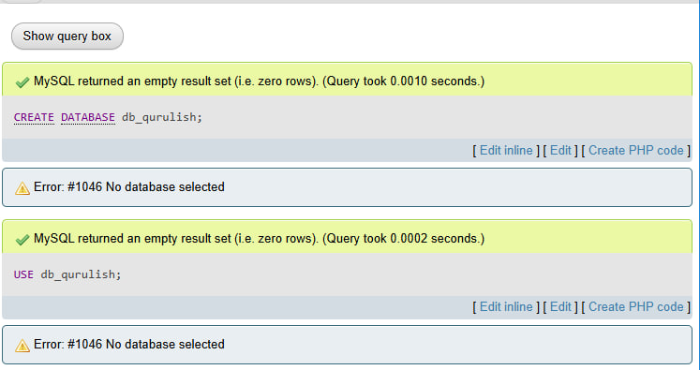
CREATE TABLE obyektlar (
id INT AUTO_INCREMENT PRIMARY KEY,
nomi VARCHAR(100),
manzil VARCHAR(150)
);
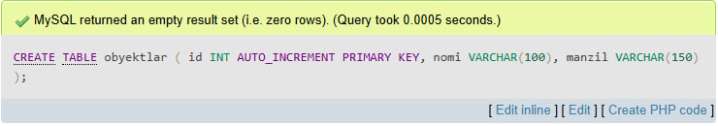
CREATE TABLE ishchilar (
id INT AUTO_INCREMENT PRIMARY KEY,
ism VARCHAR(100),
mutaxassislik VARCHAR(100)
);
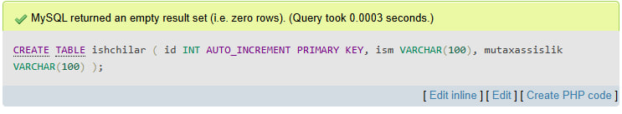
CREATE TABLE topshiriqlar (
id INT AUTO_INCREMENT PRIMARY KEY,
obyekt_id INT,
ishchi_id INT,
sana DATE,
FOREIGN KEY (obyekt_id) REFERENCES obyektlar(id),
FOREIGN KEY (ishchi_id) REFERENCES ishchilar(id)
);
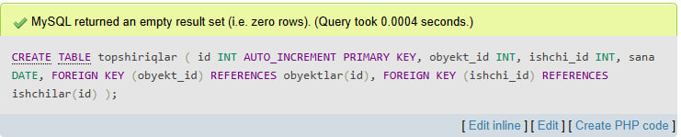
SELECT
ishchilar.ism,
ishchilar.mutaxassislik,
obyektlar.nomi,
obyektlar.manzil,
topshiriqlar.sana
FROM topshiriqlar
JOIN ishchilar ON topshiriqlar.ishchi_id = ishchilar.id
JOIN obyektlar ON topshiriqlar.obyekt_id = obyektlar.id;
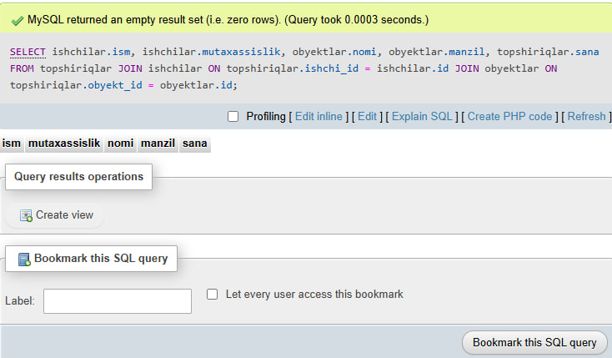

Index.php
<?php
$conn = new mysqli("localhost", "root", "", "db_qurulish");

if ($conn->connect_error) {
die("Ulanishda xatolik!");
}

/* =========================
ISHCHI QO‘SHISH
========================= */
if (isset($_POST['add_worker'])) {
$ism = $_POST['ism'];
$mutaxassislik = $_POST['mutaxassislik'];

$conn->query("INSERT INTO ishchilar (ism, mutaxassislik)
VALUES ('$ism', '$mutaxassislik')");
}

/* =========================
OBYEKT QO‘SHISH
========================= */
if (isset($_POST['add_object'])) {
$nomi = $_POST['nomi'];
$manzil = $_POST['manzil'];

$conn->query("INSERT INTO obyektlar (nomi, manzil)
VALUES ('$nomi', '$manzil')");
}

/* =========================
TOPSHIRIQ QO‘SHISH
========================= */
if (isset($_POST['add_task'])) {
$ishchi_id = $_POST['ishchi_id'];
$obyekt_id = $_POST['obyekt_id'];
$sana = $_POST['sana'];

$conn->query("INSERT INTO topshiriqlar (ishchi_id, obyekt_id, sana)
VALUES ('$ishchi_id', '$obyekt_id', '$sana')");
}

/* =========================
JOIN SO‘ROV
========================= */
$sql = "SELECT
ishchilar.ism,
ishchilar.mutaxassislik,
obyektlar.nomi,
obyektlar.manzil,
topshiriqlar.sana
FROM topshiriqlar
JOIN ishchilar ON topshiriqlar.ishchi_id = ishchilar.id
JOIN obyektlar ON topshiriqlar.obyekt_id = obyektlar.id";

$result = $conn->query($sql);

$workers = $conn->query("SELECT * FROM ishchilar");
$objects = $conn->query("SELECT * FROM obyektlar");
?>

<!DOCTYPE html>
<html>
<head>
<title>Qurilish kompaniyasi</title>
<style>
body { font-family: Arial; padding:40px; background:#f4f4f4; }
form { background:white; padding:15px; margin-bottom:20px; }
input, select { padding:8px; margin:5px; }
table { width:100%; border-collapse: collapse; background:white;}
th, td { border:1px solid #ccc; padding:10px; text-align:center; }
th { background:#667eea; color:white; }
</style>
</head>
<body>

<h2>Ishchi qo‘shish</h2>
<form method="POST">
<input type="text" name="ism" placeholder="Ism" required>
<input type="text" name="mutaxassislik" placeholder="Mutaxassislik" required>
<button name="add_worker">Qo‘shish</button>
</form>

<h2>Obyekt qo‘shish</h2>
<form method="POST">
<input type="text" name="nomi" placeholder="Obyekt nomi" required>
<input type="text" name="manzil" placeholder="Manzil" required>
<button name="add_object">Qo‘shish</button>
</form>

<h2>Topshiriq biriktirish</h2>
<form method="POST">
<select name="ishchi_id" required>
<option value="">Ishchini tanlang</option>
<?php while($w = $workers->fetch_assoc()) { ?>
<option value="<?= $w['id'] ?>"><?= $w['ism'] ?></option>
<?php } ?>
</select>

<select name="obyekt_id" required>
<option value="">Obyektni tanlang</option>
<?php while($o = $objects->fetch_assoc()) { ?>
<option value="<?= $o['id'] ?>"><?= $o['nomi'] ?></option>
<?php } ?>
</select>

<input type="date" name="sana" required>
<button name="add_task">Biriktirish</button>
</form>

</body>
</html>

Natija:
